**Ex1**

The Heisenberg principle states that the resolutions $Δt$ in time and $Δf$ in the frequency spaces must satisfy the relation $Δt.Δf≥\frac{1}{2π}$

-If the desired resolution $Δf=0.1$ in the frequency space, what should be the sliding window width in the time space?

-We want to use this window to observe two cosines with frequencies f1=0.15 and f2=0.35 in the time-frequency space (STFT). Is this window good for observing these two signals without frequency overlapping?

**Ex2**

The first temptation to observe a signal in the time-frequency space, is to truncate the signal by a sliding window $w\left(t-b\right)$ throughout the signal, and take the Fourier transform of each truncated signal, as shown in equation (1) in the case of a continuous STFT. To avoid redundancy, the truncation step (delay) $b$ should be equal to the window width $Li=Δt$.

$$X_{f,b}=\int{x(t)}.w\left(t-b\right)e^{-2jπft}dt(1)$$

The STFT is applied to a signal composed of two cosines.

a) - Determine from each figure below, the frequency and the chronological order of the two signals.

b) - Knowing that the whole signal duration is N=1024, determine the truncated intervals number and the window duration (width) in each figure.

c) - In which figure the frequency resolution is good and why?

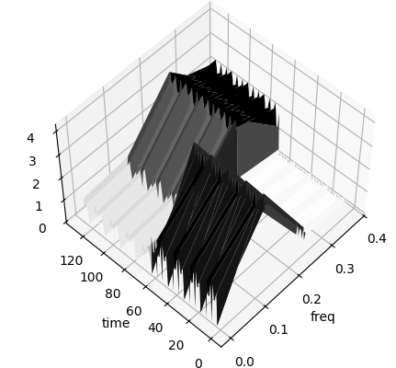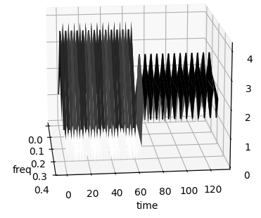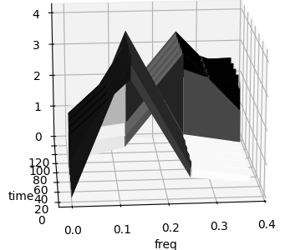

Fig.1

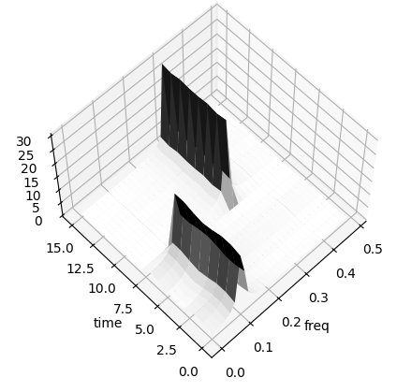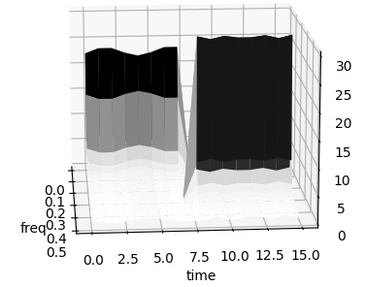 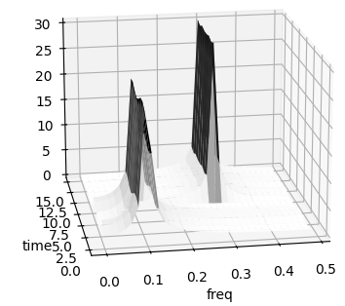

Fig.2